**ASCII**

**ASCII :** ASCII (American Standard Code for Information Interchange) is the most common character encoding format for text data in computers and on the internet. In standard ASCII-encoded data, there are unique values for 128 alphabetic, numeric or special additional characters and control codes.

ASCII encoding is based on character encoding used for telegraph data. The [American National Standards Institute](https://www.techtarget.com/searchdatacenter/definition/ANSI) first published it as a standard for computing in 1963.

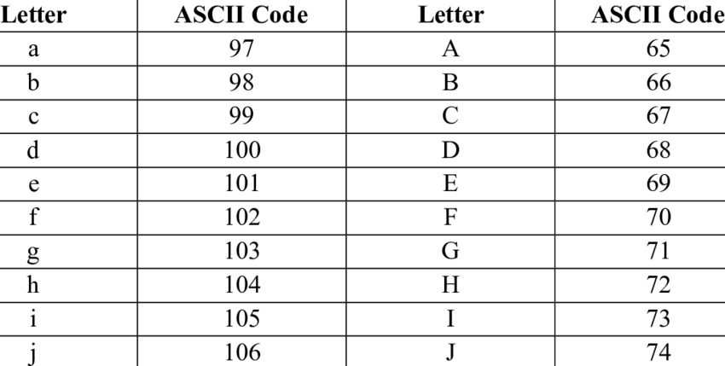

**Why is ASCII important?**

ASCII was the first major character encoding standard for data processing. Most modern computer systems use [Unicode](https://www.techtarget.com/whatis/definition/Unicode), also known as the Unicode Worldwide Character Standard. It's a character encoding standard that includes ASCII encodings.

The Internet Engineering Task Force ([IETF](https://www.techtarget.com/whatis/definition/IETF-Internet-Engineering-Task-Force)) adopted ASCII as a standard for internet data when it published "ASCII format for Network Interchange" as [RFC 20](https://datatracker.ietf.org/doc/rfc20/) in 1969. That request for comments ([RFC](https://www.techtarget.com/whatis/definition/Request-for-Comments-RFC)) document standardized the use of ASCII for internet data and was accepted as a full standard in 2015.